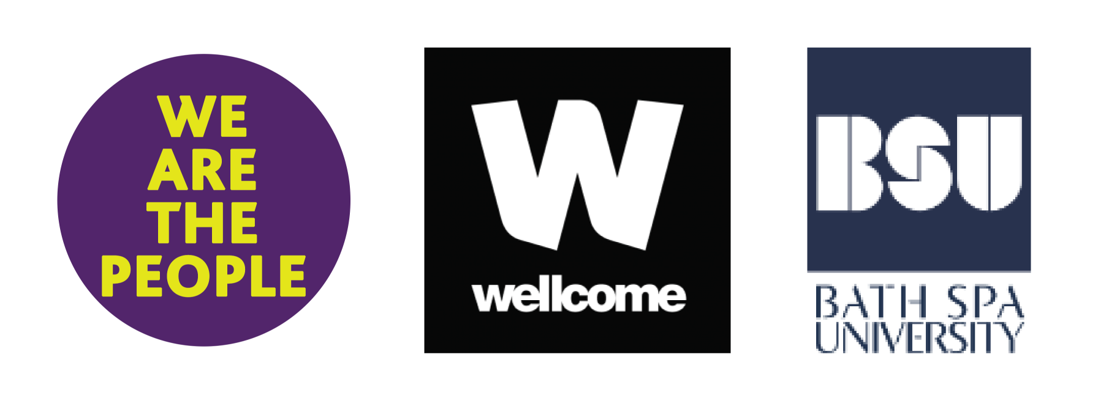

Application form
We Are The People Community Research Grant
Deadline: 23rd February 2025

Information required | Details
Name of Organisation and lead contact(s)
Please include contact details
Please provide a brief introduction to your organisation
Type of organisation, e.g. CIC, collective, Charity or Community group
Amount of funding sought.
(Maximum amount £15,000)
Please outline which topic you would like to research during this project, and how this builds on existing practice or innovates new practice that will support your groups/audience.

(maximum 250 words)
Summary of the proposed project
(maximum 250 words)
Please give details of how your organisations has worked collaboratively with any partners and how you did this. Please list any challenges you faced.

What do you hope to gain from taking part in this research project?
What do you hope this will lead to? (I.e. future funding applications, or collaborations, larger scale projects)
(maximum 250 words)
Please list items of expenditure planned and justification of these. Explain what your time commitment will be to complete the work and how this will be managed

Would you or a representative be available for a weekly meeting with a Bath Spa University Researcher? | Y/N
Please confirm a budget template has been included with a breakdown of projected costs. | Y/N

Budget breakdown
Please complete the table below with expected spends. Please include items such as staffing costs, materials and resources, room hire and any comms or advertising costs, etc. Please edit the form accordingly if necessary.

Item | Cost | Notes
 | TOTAL | £
Successful recipients of a Community Research grant must comply with the terms and conditions provided by the funder, The Wellcome Trust. As well as complying with university ethics and data regulations.

Please send completed application forms to: WeAreThePeople@bathspa.ac.uk by 23rd February 2025, at 11.59pm

.

