# **VALUE OF ARTISTS PARTICIPANT RECRUITMENT PACK**



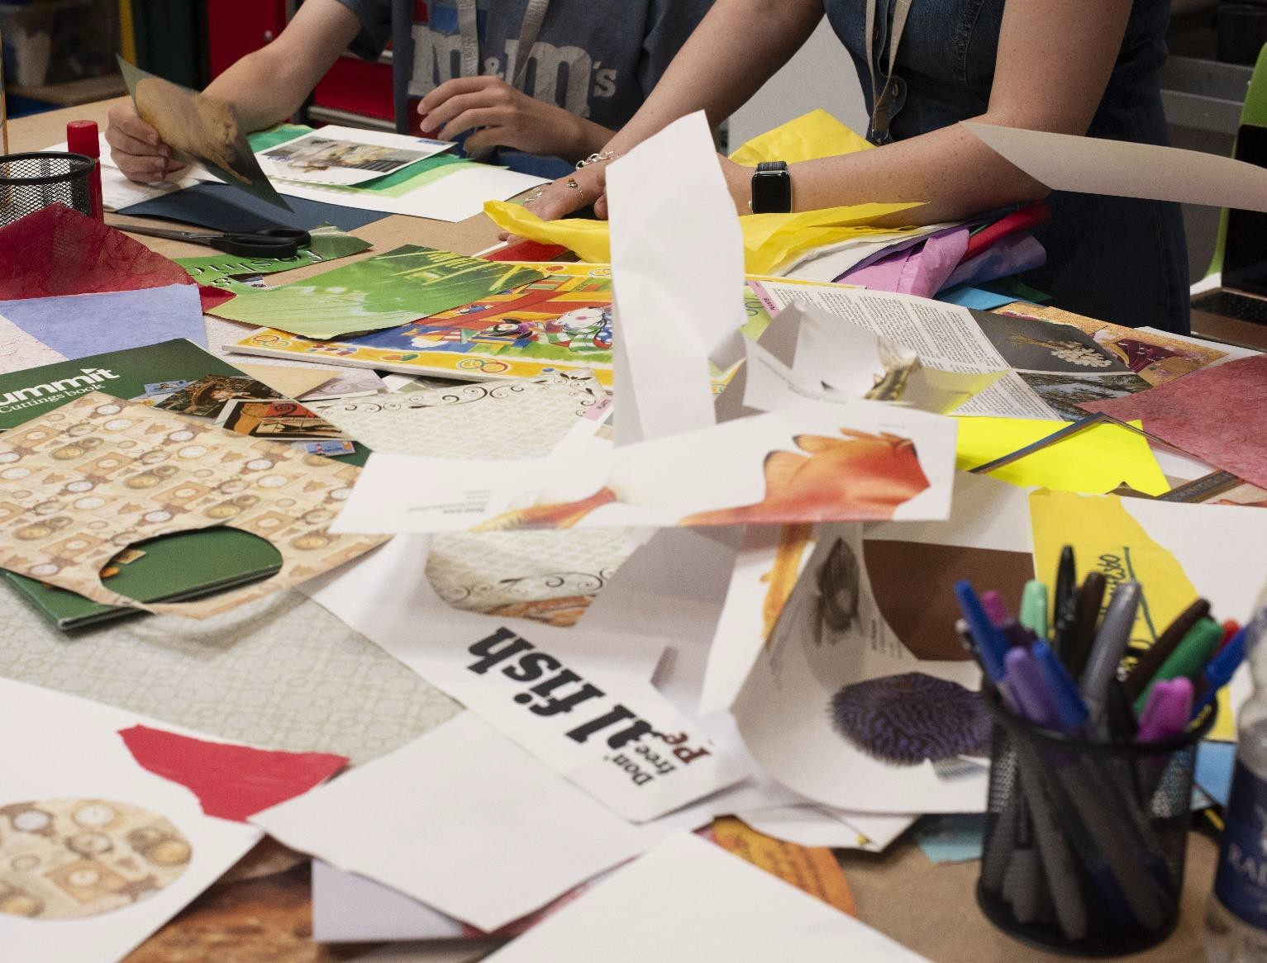

**Bath Spa University’s School of Art, Film and Media are looking for 25 creatives to take part in a two-day training programme on how to make creative learning resources. 5 participants will then be commissioned to produce resources that will be distributed across the West of England region.**

# **INTRODUCTION**

Learning Resources developed by artists play a significant role in the offer galleries or museums make to their audiences either online or in print. As a free resource, they can be vital and empowering tools for the facilitators, teachers and carers that use them.

They can have impactful reach well beyond the institution that commissioned them as they can offer a free and accessible way to bring creative work into the home, classroom or centre.

This ‘Value of Artists’ project, led by Bath Spa University’s School of Art, Film and Media, aims to offer a paid training opportunity for 25 creatives to explore creative learning resources and then to commission 5 artists from the training programme to create and produce a series of educational learning resources that explore the value of artists in society, the variety of roles they can play and the career pathways they can take. These resources will demystify the role of the artist by exposing the work they do more broadly in communities, education, climate action, health and wellbeing. The commissioned resources will be distributed for free to schools and education providers in the West of England region.

## In Summary, the Value of Artists project will:

* Provide paid professional development/training for 25 artists/creative practitioners from the region.
* Commission 5 artists/creative practitioners.
* Develop a series of online and printed resources that explore the value of artists in society, the variety of roles they can play and the career pathways they can take.
* Distribute a set of resources to schools and other relevant education providers in the region that evidence the value of art education and the career pathways it

# **THE DETAILS**

1. This project will offer a comprehensive and practical **2-day** training programme to **25** artists and creative practitioners from the West of England region. Experienced gallery educators, artists and teachers will contribute to this practice-led programme that will focus on how to develop learning resources and the impact of these valuable tools. The training will take place on **Thursday 7 and Friday 8 November 2024.**

Twenty-Five successful applicants will be paid a fee of **£150 per day** to attend the training, along with a **£20 per day travel subsidy**.

1. At the end of the training programme, participants will be invited to submit a proposal to develop a learning resource – of which **five will be selected.** The development of the resources will be supported through a series of mentoring sessions. The learning resources will be launched at a public event and made available online and in print. A series of workshops will be offered to support access to the resources for local teachers and other educators. Copies of the resource will be distributed for free to regional schools and colleges, along with alternative school provisions and youth groups.

Five selected commissioned artists will be paid a total fee of **£3000** each to develop their resources and deliver a workshop.

# **TIMELINE**

## Thursday 5 September 2024 (18:00-19:00)

## Online information session for anyone interested in applying or finding out more.

[**Register on Ticketsource**](https://www.ticketsource.co.uk/exhibitions/value-of-artists-information-session-online/e-oblrdg).

## Tuesday 1 October 2024

Deadline for applications.

## Friday 11 October 2024

Applicants notified.

## Thursday 7 and Friday 8 November 2024 (09:00-17:00)

2-day training programme to take place at Bath Spa University’s Locksbrook Campus.

## Monday 6 January 2025 (09:00)

Deadline for participants to submit proposals for the learning resource commission.

## Thursday 23 January 2025

Selected proposals notified.

## February to June 2025

Learning resource development, including mentoring and design support.

## July to August 2025

Production of learning resources.

## September 2025 (dates TBC)

Launch event at Bath Spa University’s Locksbrook Campus and workshop events.

# **CRITERIA**

* Applicants must be based in the West of England region (Bath and North East Somerset, Bristol, and South Gloucestershire) and North Somerset.
* Applicants must consider themselves creative freelancers, where their creative practice is a part of their career pathway (creative freelance work might only make up a small percentage of overall work).
* We are open to artists and creative practitioners from a variety of backgrounds. We are open to receiving applications from (but not limited to) visual artists, performers, musicians, creative technologists, makers and other creatives.

This opportunity is not available to current full-time students.

# **APPLICATION**

You will need to [**complete an online Microsoft Form**](https://forms.office.com/e/QK8hnbZ9Rr). On the form, you will be asked:

* Your name
* Your contact details
* Your postcode
* Whether you consider yourself a creative freelancer
* Whether you identify as being from an underrepresented group
* To tell us why you are interested in the opportunity (up to 200 words)
* To tell us about your interest in learning in relation to your creative practice (up to 500 words)
* To tell us how this programme will affect your practice in the long term (up to 300 words)
* Include a link to a private folder (such as a Google Drive folder or Dropbox folder) with up to 10 examples of your creative practice (such as photographs, videos or sound recordings). Please include details of the work, including title, material and scale.
* To specify if you have used AI in any part of your application process. We understand that some applicants use AI as a tool. We do ask you to ensure that the work you are submitting is your own.

## We recommend drafting your answers to the questions in a word document before copying them into the Microsoft Form.

The [**application form can be found online**](https://forms.office.com/e/QK8hnbZ9Rr)or by copying and pasting the following link: <https://forms.office.com/e/QK8hnbZ9Rr>

# **ALTERNATIVE APPLICATION FORMATS**

We would be happy to receive your application in an alternative format, such as a video or audio application. Using an alternative format will **not** impact your application and will be assessed in the same way as written applications.

You can answer all questions in your chosen alternative format or in a combination of written/alternative format.

Please see guidance on making an alternative application.

## Submitting an alternative application

Please email your application with any links to Simone Hesselberg (Creative Producer): [s.hesselberg@bathspa.ac.uk](mailto:s.hesselberg@bathspa.ac.uk)

# **ACCESS SUPPORT**

We are committed to being open and accessible to everyone. We acknowledge that certain barriers may exist for some individuals and are committed to providing additional support as needed. Below is a list of access support options available:

* Offering this guidance document as an audio recording and Etext.
* Offering the opportunity to answer questions in an alternative format (see above guidance).

Should you require further assistance or support beyond what is listed above, please do not hesitate to contact Simone Hesselberg (Creative Producer): [s.hesselberg@bathspa.ac.uk](mailto:s.hesselberg@bathspa.ac.uk)

# **EQUAL OPPORTUNITIES**

Once you have completed your application, please complete our equal opportunities monitoring form. The [**form can be found online**](https://forms.office.com/e/MVhTcbx224)or by copying and pasting the following link: <https://forms.office.com/e/MVhTcbx224>

**Data is anonymous** and will be aggregated for reporting purposes. This means that **nobody can be identified from the data**. All data will be processed in accordance with the General Data Protection Regulation and only for the purposes specified above. If you have any queries, please contact Simone Hesselberg (Creative Producer): [s.hesselberg@bathspa.ac.uk](mailto:s.hesselberg@bathspa.ac.uk)

The Value of Artists is part of the [**Culture West**](https://www.westofengland-ca.gov.uk/what-we-do/innovation/culture-west/)programme and is made possible with funding from the West of England Combined Authority and Arts Council England.

