

# Subject Knowledge Audit: Art and Design

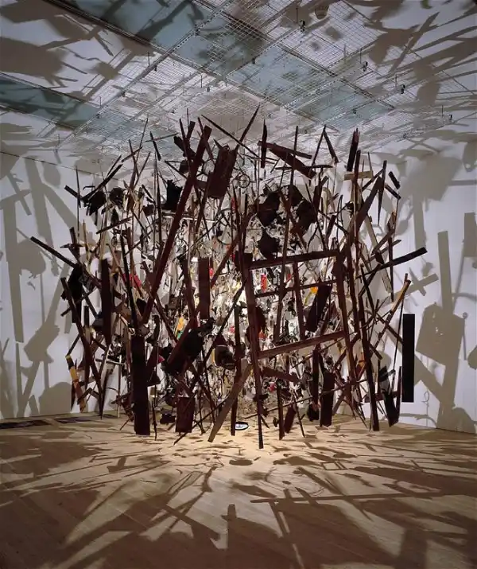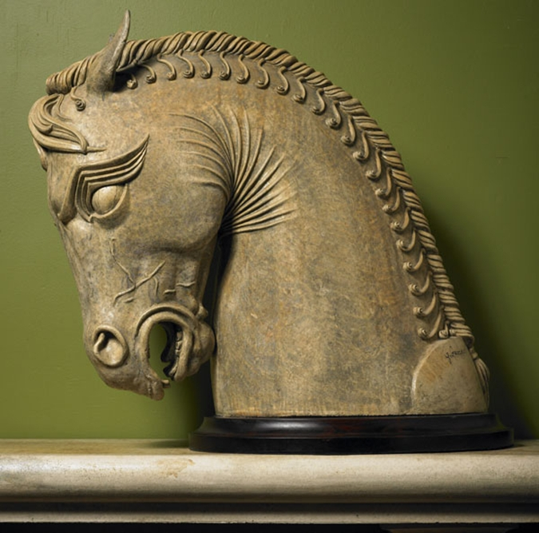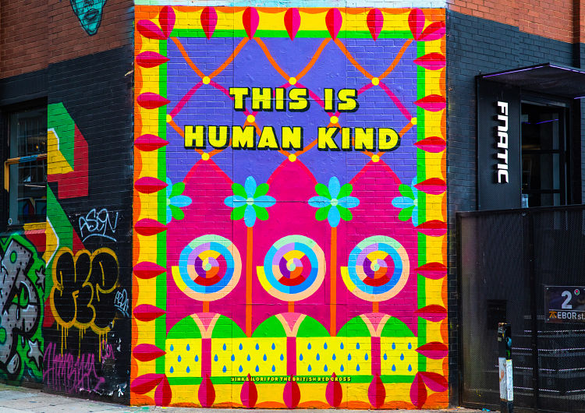

Cornelia Parker: *Cold Dark Matter,* 1991

Unknown artist: Ancient Persian Sculpture

Yikna Illori, British Red Cross Mural 2021

## CONTENTS PAGE

Introduction 3

The features of subject knowledge 4

Context 4

Your supporting evidence  6

Example entry 7

Your Subject Knowledge Audit 8

## INTRODUCTION

## The subject knowledge audit

This audit aims to do several things:

* to help you **know what** subject ‘knowledge’ means for your subject
* to help you **identify your strengths and areas for development** in subject knowledge
* to **track your progress** in developing subject knowledge and guide you in increasing your knowledge
* to play a part in helping you to provide **evidence of Components**

## THE FEATURES OF SUBJECT KNOWLEDGE IN ART AND DESIGN

There are different ways to think about subject knowledge in the context of teacher training. In its broadest sense, it can consist of the information, concepts, processes and skills in the subject, as well as the methods to teach, plan and assess it. For the purpose of this audit, the focus is mainly on the technical skills (sometimes called procedural - the practical ‘doing’) and the contextual knowledge (sometimes called declarative - the contextual and theoretical understanding) of the subject matter itself, though you should also be aware of the concepts and disciplinary processes that underpin this material.

### The need to know

No teacher knows everything about their subject and there is no way that they can. However, it is essential that you make sure that you take responsibility for continual professional development (CPD) whilst on placement. This will be supported through informal peer ‘mini teach/skill shares’ in subject specific university based sessions and access to Locksbrook and Sion Hill workshops/art areas and, of course, the library.

### Making accurate judgements

RAG (red, Orange, Green) rate your subject knowledge -

RED - insecure - poor knowledge/skills - not confident to teach

ORANGE - some knowledge/skills - could do the basics and introduce to KS3 but not in depth

GREEN is secure knowledge/skills and confident to teach up to A level to a deep level as appropriate.

What does ‘deep’ level mean?

Minimal - I’ve heard of Frida Kahlo and I have a pillow with her face on at home. She painted self-portraits.

Surface might be - I know who Frida Kahlo is, where she is from, a bit about her context and know her key works.

Deeper might be - knowing the context of her country, culture and the art movements of her time, how her work has influenced wider artists and artworks, what her artworks connect to politically and socially now.

Minimal- I did mark-making in school using a black biro to create textures

Surface I know how to use a variety of 2d media to create a variety of marks and can make aesthetic links to artists who use mark making in their artwork

Deeper I know how to use a variety of tools and processes that use concepts of ‘mark making’ in a traditional, modern and contemporary way - linking these to artists, crafts and designers works. I show understanding of how ideas around interpretations of mark-making has been used in a range of other cultures and art movements.

**Actively making and using new materials, or old materials in a new way, as well as reading course documents, researching online and careful reflection on your own teaching will improve your ability to make these judgements during the course**

## CONTEXT

In 2022, the Government released an [Ofsted review of Art and Design](https://www.gov.uk/government/publications/research-review-series-art-and-design/research-review-series-art-and-design) provision in schools, further its previous 2012 Review.

The report highlighted that the following should be of focus:

* Time for pupils to be taught the **breadth** and **depth** of knowledge required for success at KS4.
* That a range of **practical, theoretical and disciplinary knowledge** should be taught in an interlinked way
* That the **selection and sequencing of curriculum content** should be deeply considered and appropriately organised.
* Acknowledgement that the Arts Industry is a big contributor to national economic prosperity and that time should be given to arts, not to treat it as an add-on or gateway to support academic learning

Further research by the [EEF](https://educationendowmentfoundation.org.uk/education-evidence/evidence-reviews/arts-education) connected academic knowledge acquisition and enjoyment in the arts.

*There is some suggestion that the mechanisms or factors that contribute to the learning processes in most arts education are related to elements of enjoyment, engagement and extension (e.g. DeMoss and Morris 2012). Otten et al. (2004) reported that the effect of dramatic art on acquisition of history knowledge was mediated by enjoyment, which in turn, predicted future performance on standardised tests.*

Huat See and Kokotsaki : 2015

Concepts of knowledge and systems of gaining knowledge in Art and Design have been particularly explored in Arts Research for the past few decades (Sullivan, 2006) and aspects of technical/procedural making - particularly with relation to recognising and appreciating craft has been explored eloquently by Sennett (2009)

The recent [Art and Design Research Review (Thomson and Maloy, 2022)](https://www.nsead.org/files/6f85ab8587bc53ce653702da1cc15690.pdf) regarding ‘skills’ and ‘knowledge’ commented:

*Skills, techniques and practices The term skill usually refers to the learned capacity to perform a specialised activity with a high degree of precision and expertise. Skills are sometimes positioned as opposed to knowledge, but all skills are underpinned by specialist knowledges, although these may be tacit or not systematically codified. Skills are often equated with the acquisition and proficient application of particular techniques – processes. A skilful artist or craftsperson knows and can use many techniques, practices and is dedicated to refining and developing their capabilities.*

*Skills and techniques do not exist in isolation; they are the basis of social practices which have specific demands and expectations, histories, values, truths and narratives. Richard Sennett refers to craft practices as artisanal, as making good work which is not only of high quality but also does good in the world. An art practice is generally understood as skilled and more than the physical activities of making -an art practice is inclusive of ideas, influences and traditions, as well as being framed by and situated in a specific time and place. Some argue that art practice is also a form of research*

With these points in mind, considering what you know about art, craft and design and what you need to spend time further developing knowing is a key part of being an Art Teacher and developing your practice as an effective Art Teacher.

**Bibliography**

Huat See, B and Kokotsaki B. 2015 Impact of arts education on the cognitive and non-cognitive outcomes of school-aged children, Durham University, Education Endowment Foundation

Sennet, R. 2009. The craftsman. New Haven CT: Yale University Press.

Sullivan, G. 2006. Research acts in practice. Studies in Art Education 48(1): 19-35.

Thomsan, P and Maloy, L. 2022. Rapid Evidence Review: The benefits of Art, Craft and Design education, University of Nottingham, NSEAD

Ofsted. 2022. *Research Review Series: Art and Design.* Available at: https://www.gov.uk/government/publications/research-review-series-art-and-design

## SUPPORTING EVIDENCE FOR THE AUDIT

When identifying your level of subject knowledge and completing the audit you should take into consideration the following:

* **Evidence in your Art Portfolio and Sketchbooks**
* Teaching experience (including after-school clubs, etc)
* Subject specific workshops attended
* Observations of teaching practice
* Your independent research ( active making, books, websites, journals etc)

### Entries in your audit

There are six times by which date you need to update this audit.

1. At interview

#### Developing as a Teacher Phase 1

1. ITR (September)
2. PRP1 (October)

#### Consolidating and enhancing as a Teacher Phase 2 and 3

1. PRP2 (January)
2. PRP3 (April)

#### Enhancing and becoming a fully confident Teacher Phase 4

1. PRP4 (June)

### Improving subject knowledge

You will have opportunity to do this :

* As part of your professional responsibility for independent CPD
* At University Sessions
* On School Placements

## SUBJECT KNOWLEDGE AUDIT FOR ART, CRAFT and DESIGN

## Completed Example Entry over the course of the PGCE

|  |  |  |  |  |  |  |
| --- | --- | --- | --- | --- | --- | --- |
| **QTS** |  |  | |  | |  |
| **Knowledge of subject** | Inter  view | ITR | PRP  1 | PRP  2 | PRP 3 | PRP  4 |
| **Activities**:  Photography - Analogue Dark room |  |  |  |  |  |  |

## MY SUBJECT KNOWLEDGE AUDIT (Add additional activities as required)

|  |  |  |  |  |  |  |
| --- | --- | --- | --- | --- | --- | --- |
| **SUBJECT SKILLS** | |  | |  | |  |
| **ACTIVITY** | **Interview** | **ITR**  **(Sept)** | **PRP1**  **(Oct)** | **PRP2**  **(Jan)** | **PRP3**  **(April)** | **PRP4**  **(May)** |
| **Disciplinary / Procedural Knowledge (making/doing) ‘The How’** | | | | | | |
| **Art** | | | | | | |
| observational drawing |  |  |  |  |  |  |
| experimental drawing |  |  |  |  |  |  |
| painting |  |  |  |  |  |  |
| lino/ poly-printing |  |  |  |  |  |  |
| mono-printing |  |  |  |  |  |  |
| collage |  |  |  |  |  |  |
| painting |  |  |  |  |  |  |
| mixed-media |  |  |  |  |  |  |
| wire sculpture |  |  |  |  |  |  |
| cardboard sculpture |  |  |  |  |  |  |
| installation |  |  |  |  |  |  |
| photography |  |  |  |  |  |  |
| performance |  |  |  |  |  |  |
| projection |  |  |  |  |  |  |
| video |  |  |  |  |  |  |
| other |  |  |  |  |  |  |
|  |  |  |  |  |  |  |
| **Craft** | | | | | | |
| ceramics |  |  |  |  |  |  |
| jewelry making |  |  |  |  |  |  |
| puppetry |  |  |  |  |  |  |
| mask-making |  |  |  |  |  |  |
| weaving |  |  |  |  |  |  |
| mold-making |  |  |  |  |  |  |
| textiles |  |  |  |  |  |  |
| photography - analogue/traditional |  |  |  |  |  |  |
| other |  |  |  |  |  |  |
|  |  |  |  |  |  |  |
|  |  |  |  |  |  |  |
| **Design** | | | | | | |
| animation |  |  |  |  |  |  |
| photography |  |  |  |  |  |  |
| printmaking |  |  |  |  |  |  |
| adobe software |  |  |  |  |  |  |
| drawing for design/communicating ideas |  |  |  |  |  |  |
| architecture |  |  |  |  |  |  |
| 3D design |  |  |  |  |  |  |
| jewelry design |  |  |  |  |  |  |
| Product design |  |  |  |  |  |  |
| video |  |  |  |  |  |  |
| fashion |  |  |  |  |  |  |
| other |  |  |  |  |  |  |
|  |  |  |  |  |  |  |
|  |  |  |  |  |  |  |
| **Declarative Knowledge –‘The What’ eg, Critical & Contextual / theoretical knowledge of visual arts and culture** | | | | | | |
| Design/Applied Arts History write specifically eg, ceramics, fashion, textiles etc. |  |  |  |  |  |  |
| Graphic Design theory and history |  |  |  |  |  |  |
| Traditional European Art - (up to 1860s) |  |  |  |  |  |  |
| Traditional Aboriginal Australian Arts |  |  |  |  |  |  |
| Traditional African Arts |  |  |  |  |  |  |
| Traditional Indian Arts |  |  |  |  |  |  |
| Traditional Islamic Arts |  |  |  |  |  |  |
| Traditional Oriental Arts |  |  |  |  |  |  |
| Traditional South American Arts |  |  |  |  |  |  |
| Traditional North/First Nation American Arts |  |  |  |  |  |  |
| Western/European Modern Art: 1860-1960s  (Write specifically which movements, styles in the notes) |  |  |  |  |  |  |
| Contemporary Art:  (Write specifically which movements, styles in the notes) |  |  |  |  |  |  |
| Street Art |  |  |  |  |  |  |
| History of Photography |  |  |  |  |  |  |
| other |  |  |  |  |  |  |
|  |  |  |  |  |  |  |
|  |  |  |  |  |  |  |
| Widening Participation - school communities and arts practice |  |  |  |  |  |  |
| Art for wellbeing |  |  |  |  |  |  |
| Creative Careers - |  |  |  |  |  |  |
|  |  |  |  |  |  |  |
| Female artists/makers/designers |  |  |  |  |  |  |
| LGBQT+  artists/makers/designers |  |  |  |  |  |  |
| Disabled artists  artists/makers/designers |  |  |  |  |  |  |
| Black artists  artists/makers/designers |  |  |  |  |  |  |
| Other minority/world majority artists (specify)  artists/makers/designers |  |  |  |  |  |  |
|  |  |  |  |  |  |  |
| Understanding and application of formal elements of Art |  |  |  |  |  |  |
| Understanding and application of formal elements of design |  |  |  |  |  |  |
| Wider art specific vocabulary |  |  |  |  |  |  |
| Other |  |  |  |  |  |  |