# Investment Strategy governing HSBC investments

**Responsible Office:** University Executive

**Responsible Officer:** Chief Financial Officer

**Approving Authority:** Finance & Infrastructure Committee

**Date of Approval:** 1st March 2024

**Effective Date:** 1st March 2024

**Related Procedures:**

**Related University Policies:** Responsible Investment & Treasury Policy Statement

**Amended (if applicable):**

**Supersedes:**

**Next review due:** March 2025

## OVERARCHING STRATEGY & PURPOSE

1. Optimise financial return from proceeds of Green Park House, while working within the boundaries and ethical considerations of our responsible investment policy and sustainability policy.
2. Aim to outperform inflation to ensure funds do not decrease in value in real terms.
3. Ring fence cash to back the obligation to maintain Corsham Court over the lifetime of its lease, which is considered to be £10m + due to the age of the property.
4. Protect cash while plans to re-invest the proceeds of GPH are developed and worked up (3-4 year window) e.g. Locksbrook 2, Newton Park, accommodation etc.

## METHOD OF FUND MANAGEMENT

1. Given the complexity of the financial markets and instruments available, BSU will use an investment manager to manage the funds on BSU’s behalf.
2. Following a competitive exercise HSBC Private Banking were appointed to manage the funds on our behalf.
3. Risk profiles were built based on feedback from BSU’s Financial Portfolio Committee (which was set up at the time to oversee the set up of the portfolio) and HSBC structured the portfolio in response to this assessment.
4. Red lines were also laid down around investments in fossil fuel companies and the need for the portfolio to exhibit positive sustainability characteristics.
5. BSU has three investment pots with HSBC:
   1. Short term:
      1. Charities Global Sustainable (Excluding Fossil Fuels) Moderate
   2. Medium term:
      1. Charities Global Sustainable (Excluding Fossil Fuels) Growth
   3. Long term:
      1. Charities Global Sustainable (Excluding Fossil Fuels) Dynamic
      2. KKR Global Impact Fund II

## HSBC’s DISCRETIONARY METHODOLOGY

### Asset allocation

The investment decisions relating to allocation to different countries / sectors are determined by HSBC’s Asset Allocation (Strategic and Tactical) approach. All decisions are based on pre-defined metrics which are outlined in BSU’s investment mandate to ensure risk control and consistency of investment decisions.

·        **Strategic Asset Allocation (SAA):** Portfolios are managed with reference to a long-term SAA. The SAA is determined by reference to our views on the optimal long-term allocation between the relevant asset classes consistent with the client’s risk profile. The SAA is reviewed at least annually and is dependent on prevailing market valuations, volatility, and other factors.

·        **Tactical Asset Allocation (TAA):** The tactical positioning of the portfolio (i.e. its positioning at any given time relative to the SAA) is actively managed with the aim of managing short to medium-term investment opportunities and risks. This means that we will review the portfolio periodically and may make short to medium-term adjustments to the allocation between the specified asset classes, as well as to sectors, geographies, and other relevant themes. We will aim to keep the tactical positioning of the portfolio consistent with the level of risk deemed suitable for the client’s risk profile in the prevailing market conditions.

·        For **direct equity investments,** the investment team look for companies that deliver longer term value creation in a sustainable manner, purchased at an attractive valuation with improving prospects at an appropriate level of risk.

·       The ratio of fixed income to equity is determined by the risk grade of the portfolio. Each individual risk grade has an SAA determined to meet the desired risk. As such, each of the three portfolios was selected based on the agreed risk profile for each of the investment pots (Short, Medium, Long term).

## HSBC Mandate – Restrictions in place:

**Portfolio exclusions:**

1. Companies which manufacture banned Weapons
2. Any organisations within the energy sector for GICS methodology
3. Organisations identified as generating:

* >10% turnover from thermal coal extraction or power generation
* >10% turnover from shale energy extraction
* >10% turnover from arctic oil and gas exploration extraction

**Direct Equity Sector exclusions companies which have:**

1. >10% of revenue from manufacture of arms
2. >10% of revenue from manufacture of tobacco
3. >10% of revenue from the manufacture of alcohol
4. >10% of revenue from gambling
5. >10% of revenue from adult entertainment
6. Violations or risk of violations of the United Nations Global Compact Principles 1-10:

Principle 1: Businesses should support and respect the protection of internationally proclaimed human rights;

Principle 2: makes sure that they are not complicit in human rights abuses;

Principle 3: businesses should uphold the freedom of association and the effective recognition of the right to collective bargaining;

Principle 4: the elimination of all forms of forced and compulsory labour;

Principle 5: the effective abolition of child labour;

Principle 6: the elimination of discrimination in respect of employment and occupation;

businesses should support a precautionary approach to environmental challenges;

Principle 8: undertake initiatives to promote greater environmental responsibility;

Principle 9: encourage the development and diffusion of environmentally friendly technologies; and

Principle 10: businesses should work against corruption in all its forms, including extortion and bribery.

These exclusions are reported on via HSBC reporting (See below example from May 2024):

A graph showing 

Portfolio exclusions:
Banned Weapons 0%
Arctic Oil 0%
Thermal Coal Extraction 0%
Thermal Coal Power Generation 0%
Shale Energy Extraction 0%
GICS Energy Sector 0.4%

Direct Equity exclusions:
Alcohol Production 0%
Gambling 0%
Adult Entertainment 0%
Manufacture of armaments o%
Violations/at Risk of violations of UNGC 0%
Tobacco Production 0%

Source: Sustainalytics, data as of May 2024

### Sustainability

As well as the exclusions in place above HSBC as our investment fund managers have an objective to achieve an improvement in ESG score and reduction in carbon intensity relative to a reference portfolio, while still ensuring the Portfolio is well diversified and holds the mix of assets that HSBC believe will deliver the best risk-adjusted returns.

Sustainable criteria are applied across fulfilment vehicles (direct equity holdings, equity fund holdings, bond holdings, bond fund holdings). These sustainable criteria will include ESG integration and investment restrictions on the direct equity allocation and an Energy investment restriction on indirect investments.

The indirect allocations will use a combination of sustainable investment methods including, but not limited to, norms-based screening, exclusionary screening ESG integration and positive screening.

*NB: Direct equity allocation means where BSU holds shares in companies directly. Indirect equity or bond allocation means where BSU has bought into an investment fund which will hold a variety of equities, bonds or other asset classes as determined by that particular fund’s strategy.*

The objective of achieving an improved ESG score is calculated using MSCI data and carbon intensity using S&P Trucost data.

BSU’s ESG and carbon scoring of investments against a reference market portfolio as at May 2024:

Screenshot of graph showing that:
As at 31st May 2024, the MCSI ESG Score for BSU investments stood at 7.41 which is an 11% improvement on a reference market portfolio which scored 6.65.
 
As at 31st May 2024, according to S&P Trucost data, the corporate carbon intensity of BSU investments stood at 35 carbon dioxide equivalent per million US dollar revenue which is 72% lower than the reference market portfolio which stood at 124 carbon dioxide equivalent per million USD revenue. Carbon dioxide equivalent has been calculated using scope 1 and 2 emissions only.

HSBC additionally provides reporting of the investments against the UN SDGs.

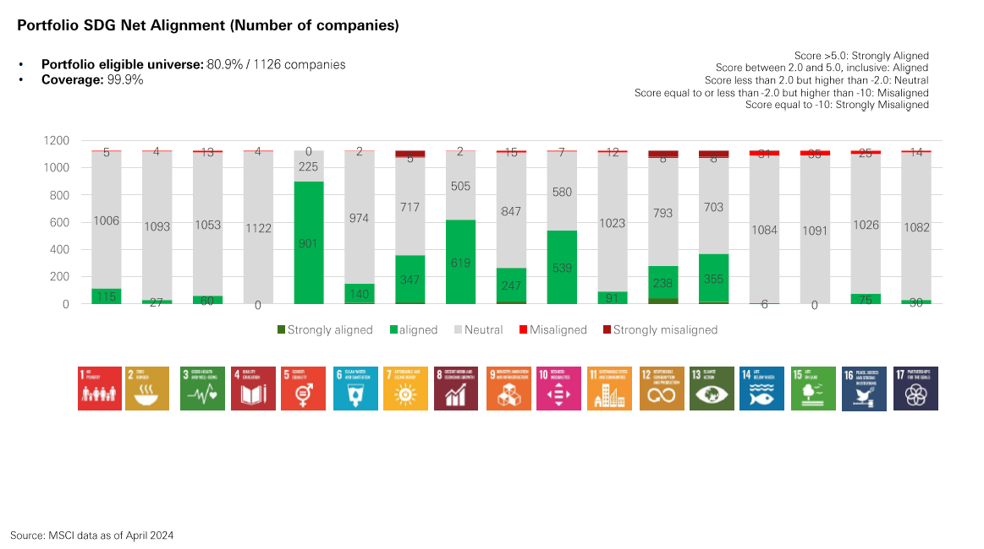

## KPIs & FINANCIAL BENCHMARKING

Given BSU’s aims (covered in para 1) benchmarking of performance will be important and as stated in the investment mandate, the benchmarking in use is a composite of the following

| **Index** | **Moderate** | **Growth** | **Dynamic** |
| --- | --- | --- | --- |
| MSCI AC World Index Net | 55.00% | 70.00% | 85.00% |
| Bloomberg Global Agg Treasuries TR Index Hedged | 24.00% | 14.00% | 4.50% |
| Bloomberg Global Aggregate Corporate Hedged | 14.00% | 9.00% | 3.50% |
| Bloomberg EM Local Currency Government TR | 5.00% | 5.00% | 5.00% |
| Bloomberg Term 1 Month TR | 2.00% | 2.00% | 2.00% |
|  | 100.00% | 100.00% | 100.00% |

## GOVERNANCE

The trustees have ultimate responsibility for making these investments on BSU’s behalf. Their role is covered by the document recently published by the government (appendix C).

Governance of the Investment Framework is outlined in Appendix A to the Terms of Reference of the Finance and Infrastructure Committee (as presented in other items to this meeting), which provides routes of assurance of oversight and governance for investment decisions.

The appointment of a governor with investment or financial instrument experience is considered optimal when a charity has oversight of an investment portfolio.

The CFO is the subject matter expert (SME) representing BSU Exec in advising the BSU Board and liaising with HSBC. The CFO may take independent financial advice when appropriate to support the investment strategy and decision making.

## RELATIONSHIP MANAGEMENT

The relationship with our investment manager, HSBC is covered by the investment mandate we signed on setting up the portfolio. It covers the decisions HSBC can make on our behalf and those they cannot make. What funds may be held and what funds may not be.

The term of the relationship is not defined but it is implicit in the performance related nature of the relationship that if performance indicated by the two KPIs are not met then intervention may be necessary and alternative investment management options or providers considered.